Electric Power Systems Research

Dear Dr. Nucci,

Kindly find attached paper entitled “Distance Protection Zone 3 Misoperation During System Wide Cascading Events: The Problem and a Survey of Solutions” which we are submitting for exclusive consideration for Electric Power Systems Research.

Distance protection misoperation has been the reason for major blackouts around the world. Distance protection misoperation can occur due to various reasons but we only focus on misoperation due to heavy loading conditions. Distance protection misoperation due to heavy loading conditions was the main reason behind the 2003 US-Canada blackout and the 2015 Turkish Blackout.

In this paper, we review the distance protection principle and show that when the system is stressed, distance protection becomes inherently insecure in zone 3. We then review the solutions to the distance protection misoperation problem due to heavy loading conditions that were given in literature.

Finally, we hope you and the reviewers find the paper enjoyable as we found it during preparation, writing and proof reading.

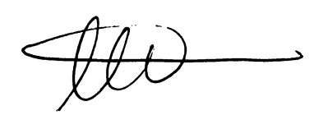

Ahmad Abdullah

Power System Design Engineer

Electric Power Engineers Inc.,

Austin, TX, 78738